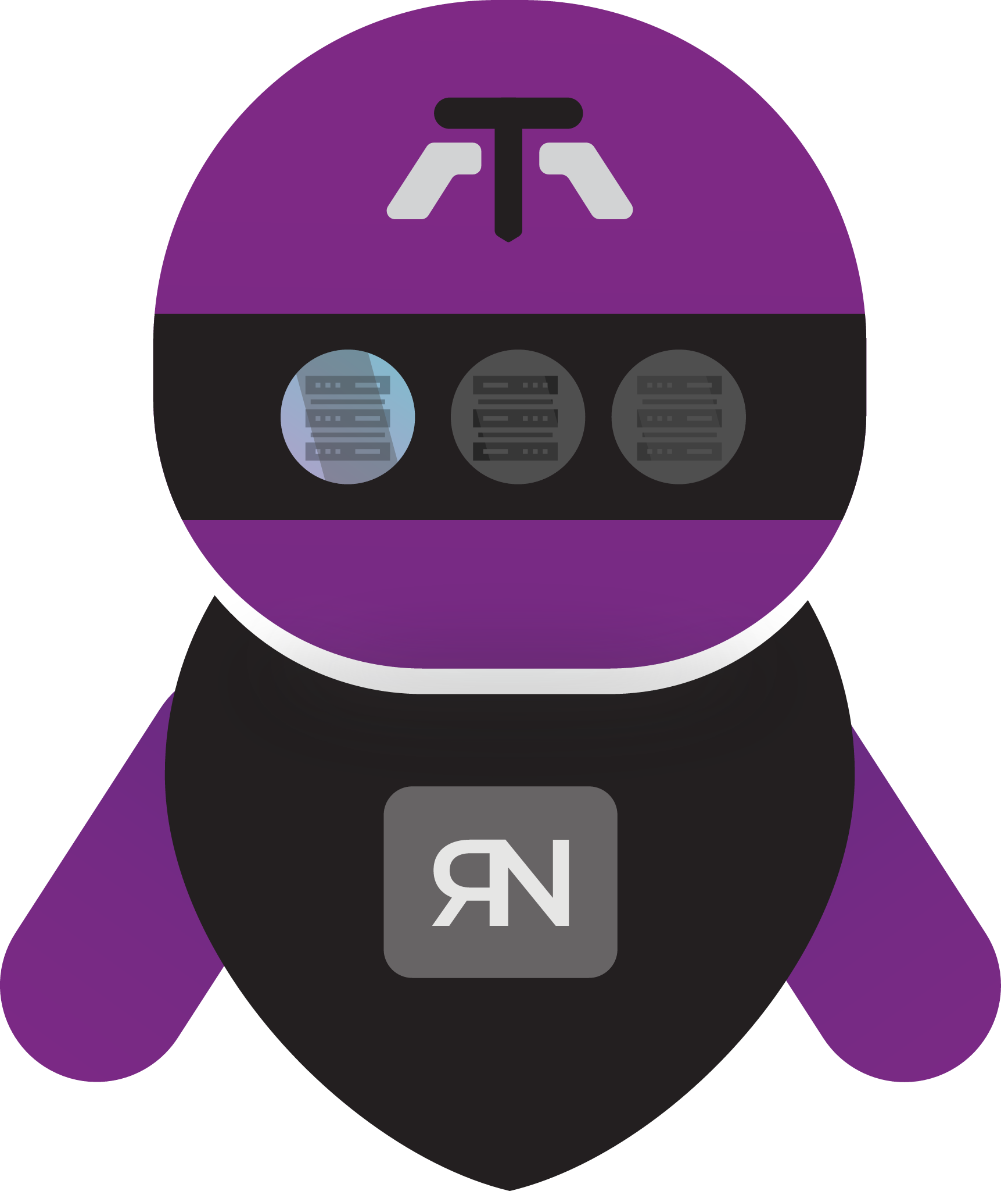

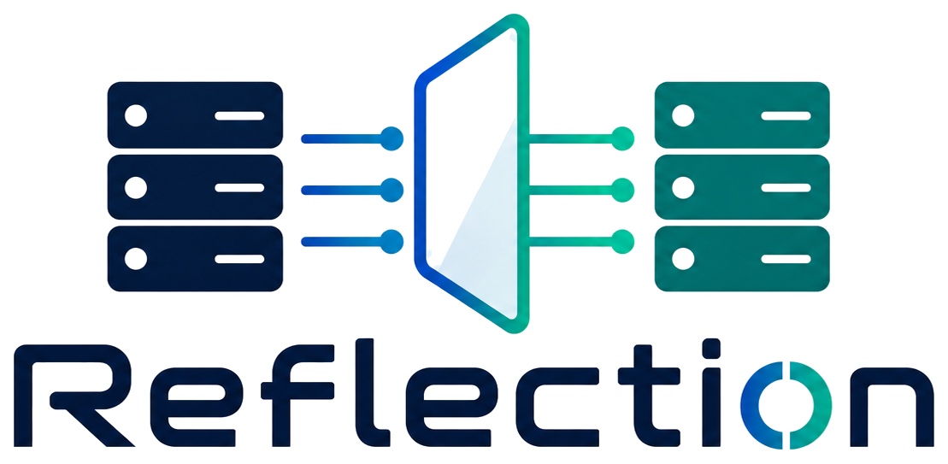

Client Handover Manual
Part I Deployment & Installation Guide
Part II Administrator & Operations Manual

Tekmonks

Contents
Deployment & Installation Guide 3
1 What Reflection does 4
2 Components and where they run 4
3 Requirements 4
4 Before installation: choose ports and firewall rules 5
5 Installation 5
6 Secure the configuration first 5
7 Configure a standard TCP relay 6
7.1 Mirror host: conf/mirror.json 6
7.2 Reflector host: conf/reflect.json 6
7.3 Start order and test 7
8 TCP, UDP, and multi-service launch commands 7
8.1 Multiple TCP mappings 7
Administrator & Operations Manual 9
9 Configuration reference 10
9.1 conf/reflect.json 10
9.2 conf/mirror.json 11
9.3 Worker and logging configuration 11
10 Optional extensions and data handling 11
11 Optional firewall control 12
11.1 Firewall administration commands 12
11.2 Geolocation firewall rules 13
12 Production service management 14
13 Operation and validation checklist 14
14 Troubleshooting 15

Part I

Deployment & Installation Guide

In this part
1 What Reflection does
2 Components and where they run
3 Requirements
4 Before installation: choose ports and firewall rules
5 Installation
6 Secure the configuration first
7 Configure a standard TCP relay
8 TCP, UDP, and multi-service launch commands

1 What Reflection does
Reflection publishes a TCP or UDP service that is reachable from a public mirror server, while the real service stays on a private reflector server. A reflector creates encrypted control/data channels to the mirror. When a client connects to the published mirror port, Reflection assigns one channel and connects to the configured origin service.
Client → public mirror:published port → encrypted Reflection channel → reflector → private origin service
Figure 1. Connection path from a client to the private origin service.
This is a transport-layer relay. It does not understand HTTP, TLS, databases, or application protocols; it forwards TCP streams or UDP datagrams. Use it only where a reverse TCP/UDP relay is the intended architecture.

2 Components and where they run
Table 1. Reflection components and where they run.
Component | Run on | Purpose
Mirror | Public/reachable host | Receives reflector control/data channels and opens the client-facing listener on demand.
Reflector | Network that can reach the origin | Connects to the mirror, maintains a TCP channel pool, and opens connections to the origin.
Origin service | Usually private | The existing TCP/UDP service being made reachable. It is not part of this repository.

3 Requirements
- Node.js with the built-in net, dgram, crypto, cluster, and filesystem modules. The repository has no package.json and no third-party Node dependency install step.
- Two hosts with network connectivity from reflector to mirror control/data ports.
- An origin service reachable from the reflector on the configured host and port.
- Permission to listen on the selected ports. Use ports above 1024 unless the service account has the required capability.
- The mirror and reflector must use the same conf/crypt.json values. Control traffic and TCP relay control messages use the shared key; the optional AES extension has its own conf/aes.json secret.
Check Node before deployment:
node --version
node -e "require('net'); require('dgram'); require('crypto'); console.log('Node runtime OK')"

4 Before installation: choose ports and firewall rules
Choose non-conflicting ports. Do not expose the control, heartbeat, or firewall-control ports to the Internet. Restrict them to reflector/admin addresses. The published service port is the only port normally open to clients.
IMPORTANT · UDP
The implementation starts its heartbeat server with Node’s TCP net API even for the UDP mode. Keep the heartbeat port reachable over TCP until a future release.

5 Installation
Perform these steps on both hosts.
- Copy the complete reflection directory to a stable location, for example /opt/reflection.
- Create a non-login service account, for example reflection.
- Give that account ownership of the installation and ensure it can create /opt/reflection/logs.
- Keep conf/ readable only by the service account because it contains secrets.

6 Secure the configuration first
The supplied configuration contains sample/default secrets and example addresses. Treat it as a template, not production configuration.
- Generate two new high-entropy secrets: one for key, one for heartbeat_key.
- Put them in conf/crypt.json on both hosts, with identical values.
- If using the AES traffic extension, replace conf/aes.json with the encrypted AES key expected by extensions/aes.js; otherwise do not enable that extension.
WARNING
Never put secrets directly in source control. Any string config value may instead use env:VARIABLE_NAME; Reflection resolves it from the process environment at startup.

Example crypt.json pattern using environment variables:
{
"key": "env:REFLECTION_CONTROL_KEY",
"heartbeat_key": "env:REFLECTION_HEARTBEAT_KEY",
"fips_mode": false
}
Set those environment variables in the service manager, not in a world-readable shell file. Both endpoints must receive exactly the same values. If FIPS is enabled on the installation system, then change fips_mode flag as true.

7 Configure a standard TCP relay

7.1 Mirror host: conf/mirror.json
Set the bind addresses and shared control ports. A conservative example:
{
"host": "0.0.0.0",
"port": 2000,
"heartbeat_tcp": 2001,
"keep_alive": 1000,
"timeout": 300000,
"firewall_enabled_tcp": false,
"firewall_enabled_udp": false
}
port is the Reflection control/data port, not the client-facing service port. The reflector asks the mirror to create the client-facing listener dynamically. host should be a specific public or private address where possible; use :: only when intentionally accepting IPv6.

7.2 Reflector host: conf/reflect.json
For an origin service at 10.0.0.25:8080, published as mirror port 1201:
{
"reflected_host": "10.0.0.25",
"reflected_port": 8080,
"mirror_host": "<mirror_ip>",
"mirror_port": 2000,
"mirror_heartbeat_tcp": 2001,
"mirror_service_host": "0.0.0.0",
"mirror_service_port": 1201,
"mirror_force_listener": true,
"pool_size": 5,
"mirror_connect_timeout": 20000,
"heartbeat_check_interval": 60000,
"dhcp_check": true,
"logfile": "reflector_tcp.log.ndjson"
}
reflected_* identifies the origin from the reflector’s network. mirror_* identifies the mirror control endpoint. mirror_service_* defines the public listener created on the mirror. pool_size is the number of idle TCP channels; it also caps the number of simultaneous TCP client sessions for this mapping. Size it for expected concurrency plus a small buffer.
For IPv4/IPv6 UDP, also set mirror_hostudpv4, mirror_hostudpv6, mirror_service_host_udpv4, mirror_service_host_udpv6, and ipv6enabled appropriately. Disable IPv6 (false) unless both hosts and firewall rules support it.

7.3 Start order and test
Start the mirror first, then the reflector:
cd /opt/reflection
node --env-file=.env mirror_tcp.js
cd /opt/reflection
node --env-file=.env reflect_tcp.js
NOTE
Do not regard an open TCP port alone as proof of success: confirm an actual application response.

curl -v http://<mirror_ip>:1201/

8 TCP, UDP, and multi-service launch commands
Table 2. Launch commands for each deployment mode.
Use case | Mirror command | Reflector command
TCP | node mirror_tcp.js | node reflect_tcp.js
UDP | node mirror_udp.js | node reflect_udp.js
Many TCP mappings | node mirror_tcp.js | node massreflect_tcp.js

8.1 Multiple TCP mappings
Use conf/massreflect.json when one reflector publishes multiple origins or multiple reflectors use the same mirror.
Each reflected_hosts string follows this syntax:
"origin-host:origin-port->published-bind-address:published-port"
NOTE
Can leave the Mirror_hostsudpv6 blank if using ipv4.

[
{
"reflected_hosts": ["216.116.72.174:80->[::]:1201","216.116.72.174:443->[::]:1202"],
"mirror_host": "<mirror_ip>:<mirror_port>",
"mirror_hostsudpv4": "<mirror_ipv4>:<mirror_port>",
"Mirror_hostsudpv6": "<mirror_ipv6>:<mirror_port>",
"mirror_heartbeat_tcp": 2001,
"mirror_heartbeat_udp": 1002
}
]

Part II

Administrator & Operations Manual

In this part
9 Configuration reference
10 Optional extensions and data handling
11 Optional firewall control
12 Production service management
13 Operation and validation checklist
14 Troubleshooting

9 Configuration reference

9.1 conf/reflect.json
Table 3. Reflector configuration keys.
Key | Meaning
reflected_host,  reflected_port | Origin address and port, reachable by the reflector.
mirror_host,  mirror_port | Mirror TCP control/data endpoint.
mirror_hostudpv4,  mirror_hostudpv6 | UDP mirror addresses.
mirror_heartbeat_tcp,  mirror_heartbeat_udp | Mirror heartbeat ports.
mirror_service_host,  mirror_service_port | TCP public bind address and port created on the mirror.
mirror_service_host_udpv4,  mirror_service_host_udpv6 | UDP public bind addresses.
mirror_force_listener | Replaces an existing listener for the mapping when true; avoid sharing a published port between reflectors.
pool_size | Idle TCP channel count / per-mapping concurrency ceiling.
mirror_connect_timeout | Control/UDP connection timeout in milliseconds.
heartbeat_check_interval | Heartbeat interval in milliseconds.
mirror_heartbeats_lost_for_exit | Consecutive failed beats tolerated before exit; supervisor should restart it.
dhcp_check,  dhcp_check_interval | Exits when non-internal network interface addresses change; enable when a supervisor will restart after address changes.
reflector_channel_check_wait | Exit if the TCP channel pool is empty longer than this many milliseconds.
keep_alive | TCP keepalive delay in milliseconds; use -1 to skip.
ipv6enabled | Enables UDP IPv6 socket use.
udp_cleanup_interval | Idle UDP mapping cleanup time in milliseconds; -1 means no cleanup.
logfile | TCP reflector log filename below logs/.

9.2 conf/mirror.json
Table 4. Mirror configuration keys.
Key | Meaning
host,  port | TCP mirror bind address and Reflection control/data port.
hostudpv4,  hostudpv6 | UDP bind addresses.
heartbeat_tcp,  heartbeat_udp | Heartbeat server ports.
keep_alive,  timeout | TCP channel keepalive and idle timeout.
udp_cleanup_interval | Idle UDP client mapping cleanup period.
ipv6enabled | Whether mirror UDP also binds IPv6.
firewall_* | Optional admission-control settings; see next section.

9.3 Worker and logging configuration
cluster_reflector.json and cluster_mirror.json set workers; 0 means use CPU count, subject to min_workers. More mirror workers add their worker index times offset_window to mirror, heartbeat, and firewall ports. In a multi-worker deployment, open and document each offset port; keep workers: 1 for a simple client installation.
log.json controls debug logging, synchronous writing, and the nominal max_log_mb. Logs are newline-delimited JSON in logs/. Rotate and retain them with the operating system’s log facility; do not rely solely on the application’s maximum-size setting.

10 Optional extensions and data handling
conf/extensions.json defines an ordered extension chain. The supplied default enables both traffic recorder and traffic logger.
Table 5. Extensions supplied with Reflection.
Extension | Configuration | Effect | Handover advice
trafficlogger | trafficlogger.json | Writes metadata and payload chunks to logs/traffic.log; payloads are Base64 by default. | Disable in production unless it is required and retention/access controls are approved.
trafficrecorder | trafficrecorder.json | Writes raw inbound/outbound payload streams to logs/capture.log.in and .out. | Treat as sensitive capture data; normally disable.
aes | aes.json | Adds framed AES payload encryption for TCP only. | Add only after both ends use matching extension order/key and an end-to-end test succeeds.

Set both logger/recorder enabled values to false to stop payload capture. Ensure the logs/ directory exists before enabling extensions.
NOTE
Extension order matters: outbound processing runs in reverse order, so both ends must have the same list/order.

To enable aes extension add {"extension": "aes"} in extension.json

11 Optional firewall control
When firewall_enabled_tcp or firewall_enabled_udp is true, a newly created mirror listener denies traffic unless the source IP is explicitly allowed or passes the configured geography rules.
WARNING
The firewall control port is powerful and must be network-restricted.

11.1 Firewall administration commands
These commands manage IP access to client-facing listeners on the mirror. Set firewall_enabled_tcp: true on the mirror and restrict the firewall-control port to trusted administrators.
node lib/firewall.js open CLIENT_IP PUBLISHED_PORT MIRROR_HOST FIREWALL_CONTROL_PORT [sfw_mode|heartbeat_mode]
Allows CLIENT_IP to connect to PUBLISHED_PORT. Use all instead of PUBLISHED_PORT to target every active listener.
- sfw_mode: automatically revokes access when that client’s TCP session ends.
- heartbeat_mode: keeps access only while periodic heartbeat commands continue.
node lib/firewall.js close CLIENT_IP PUBLISHED_PORT MIRROR_HOST FIREWALL_CONTROL_PORT
Revokes CLIENT_IP’s access to PUBLISHED_PORT and disconnects that IP’s currently active sessions. Use all to revoke it from every active listener.
node lib/firewall.js heartbeat CLIENT_IP PUBLISHED_PORT MIRROR_HOST FIREWALL_CONTROL_PORT
Refreshes an existing rule created with heartbeat_mode. It does not create or reopen a rule. If these heartbeats stop, the mirror removes the allowance after firewall_timeout_for_heartbeat_mode_autoclose.
node lib/firewall.js check CLIENT_IP PUBLISHED_PORT MIRROR_HOST FIREWALL_CONTROL_PORT
Checks whether CLIENT_IP would currently be allowed to access PUBLISHED_PORT, considering explicit firewall rules and configured geofencing.
Example:
node lib/firewall.js open 203.0.113.10 9898 mirror.example.com 2003 heartbeat_mode
node lib/firewall.js heartbeat 203.0.113.10 9898 mirror.example.com 2003
node lib/firewall.js check 203.0.113.10 9898 mirror.example.com 2003
node lib/firewall.js close 203.0.113.10 9898 mirror.example.com 2003
NOTE
Geofencing may contact the configured external HTTP geolocation endpoint. Consider privacy, egress controls, and dependency availability before enabling it.

11.2 Geolocation firewall rules
Geolocation is configured on the mirror in conf/mirror.json; there is no separate firewall CLI command for it.
{
"firewall_geofencing_additive": ["ML", "SG", "JP", "private_blocks", "localhost"],
"firewall_geofencing_subtractive": ["RU", "CN"],
"firewall_geo_server": "www.geoplugin.net",
"firewall_ip_cache_size": 2000000
}
- firewall_geofencing_additive — automatically allows clients whose location matches an entry, even if no explicit open command was issued.
Valid country entries are ISO two-letter country codes, such as "IN", "SG", or "US".
- firewall_geofencing_subtractive — always denies matching client locations. This takes precedence over an explicit open firewall rule.
- firewall_geo_server — hostname used to look up public client IP locations. The current implementation calls it over HTTP on port 80.
- firewall_ip_cache_size — maximum number of IP-to-location lookups retained in memory.
Example: allow India, Singapore, and private-network addresses by default, but block Russia and China:
{
"firewall_enabled_tcp": true,
"firewall_geofencing_additive": ["IN", "SG", "private_blocks", "localhost"],
"firewall_geofencing_subtractive": ["RU", "CN"],
"firewall_geo_server": "www.geoplugin.net"
}
NOTE
Restart the mirror after changing these settings. If the geolocation service cannot be reached, an unknown public IP is not automatically allowed by the additive list; use open for explicit access where needed.

12 Production service management
Run each long-lived command under systemd, a container supervisor, or an equivalent process manager. Reflection intentionally exits when it loses connectivity, misses required heartbeats, or detects an address change; a supervisor must restart it.

13 Operation and validation checklist
- Check that the mirror process is running and listening on the configured control port.
- Check that each reflector process is running and that its log shows an active mirror listener and pool/channel activity.
- Test one application request through every published service port from the intended client network.
- Review logs/*.ndjson for [access], connection errors, heartbeat failures, and firewall blocks.
- Check disk usage under logs/, particularly if traffic capture is enabled.
- After any secret or configuration change, restart the mirror and reflector together and repeat the end-to-end test.
Useful checks:
ss -lntup
tail -f /opt/reflection/logs/mirror_tcp.log.ndjson
tail -f /opt/reflection/logs/reflector_tcp.log.ndjson

14 Troubleshooting
Table 6. Symptoms, likely causes, and corrective action.
Symptom | Likely cause and action
Reflector cannot start listener | Verify mirror hostname/port, network ACLs, matching crypt.json, and that the requested published port is free.
Mirror says no reflector is available | The reflector is down, cannot reach the mirror, has a key mismatch, or all TCP pool channels are allocated. Check reflector logs and raise pool_size if concurrency is expected.
Listener disappears | The mirror closes a listener when its last reflector channel closes. Restore the reflector; supervisor restart should recreate it.
Heartbeat exits a reflector | Verify the mirror heartbeat port and matching heartbeat key. Check heartbeat_check_interval, route/firewall, and the failure threshold.
Traffic reaches mirror but not origin | From the reflector host, test reflected_host:reflected_port directly. Verify DNS, routing, and origin ACLs.
UDP has no response | Check UDP ACLs in both directions, IPv4/IPv6 fields, cleanup timeout, and the TCP heartbeat reachability note.
Firewall blocks clients | Confirm the firewall feature is enabled intentionally, the client source IP is correct (including NAT), and send an open command to the trusted control port.
Logs grow quickly | Disable traffic logger/recorder, reduce debug logging, rotate logs/, and review data-retention obligations.
Service continuously restarts | Inspect the application log first. Common causes are unavailable mirror/origin, interface changes with dhcp_check, zero TCP channels beyond the configured wait, and conflicting ports.

